Project Billing

Revision History

|  |  |  |  |
| --- | --- | --- | --- |
| Version No | Date | Prepared by / Modified by | Significant Changes |
| 1.0 | 16/06/2022 | Abhiram S | - |
|  |  |  |  |

**Table Of Contents**

* 1. Project Overview ................................................................................................................3

1.2 Scope .................................................................................................................................3

1.3 Out of Scope .......................................................................................................................3

1.4 Intended Audience .............................................................................................................3

1.5 High Level Use Cases............................................................................................................4

1.6 Use Cases detailed................................................................................................................4

1.7 User Interface Modules .......................................................................................................4

1.8 Technical Architecture..........................................................................................................4

1.9 Technical Detailed Description.............................................................................................4

1.10 Sequence Diagram .............................................................................................................5

1.11 Standards ...........................................................................................................................5,6

* 1. Project overview

The project billing is console based java application. The application is used to display the bill for the products in any shops. All the details like name, mobile number, product name, product price and quantity, discount are manually given by the user.

* 1. Scope

The scope of testing includes the bill format, Displayed date, price calculation, displaying the bill.

* 1. Out of scope

The features like the font color, font style.

Storing of details in database will be included in next build.

* 1. Intended Audience

Our target audience is the small scale shop keepers. Large shops shopping mall or shopping complex have their handheld scanner they will automatically give every details to the user. But what about small shops where the people go mostly, compared to big shops the small shops are more in number. This application will helpful for the shop keepers to display and store bill.

* 1. High level use cases

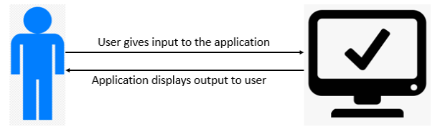

* 1. Use cases detailed

In this use case the user that is a shopkeeper gives the inputs like the name of customer, mobile number, number of products and product details then the application will display the bill in a well formatted way.

* 1. User interface modules

The only interface for the module is the console screen which enables the user to interact with the application to give input and get output.

* 1. Technical detailed description

The application is completely based on java programming language. The application asks the user for the name and mobile number then the number of products. When the user enters the number of products the system will ask for product name, price and quantity for the number of products, that is done by the use of array.

1.9 Sequence diagram

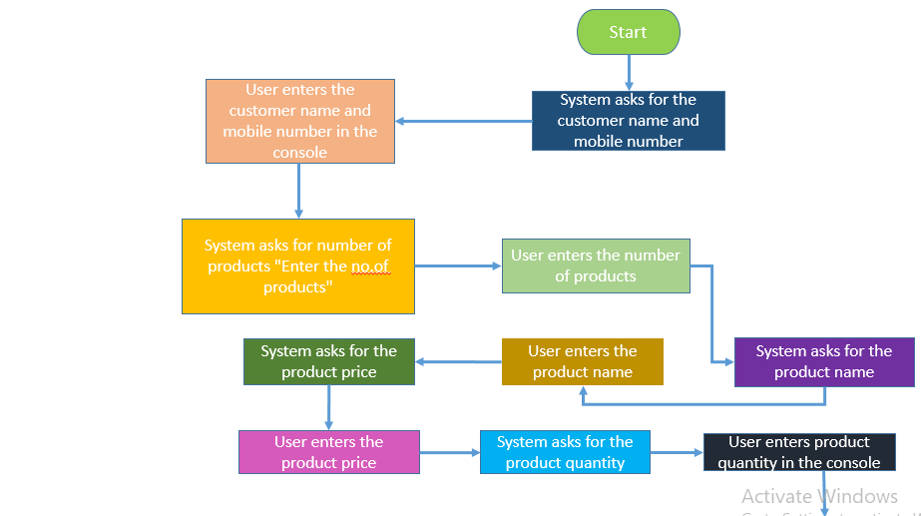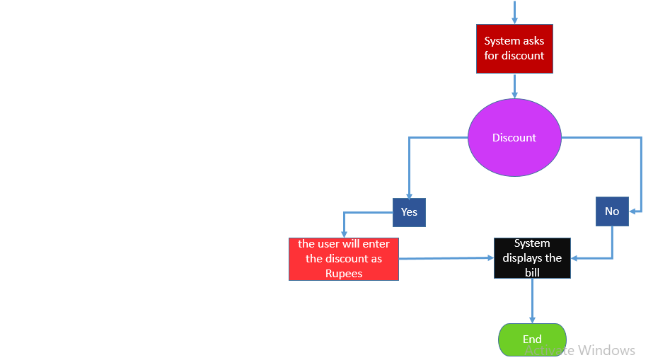

1.10 Standards

**Billing** – Application name.

**Customer name** – Name of the customer who comes to shop to buy products.

**Number of products** – It is the total number of products that the customer bought.

**Product name** – the name of the product that the customer is buying.

**Price** – the standard price for the product if the quantity is calculated in numbers the price is for 1 product, if the quantity is calculated in kg/ grams then the price is for 1kg of the product, if the quantity is calculated in litres then the price is for 1 litre of product.

**Quantity** – the quantity can the how much he bought that product. It can be numbers, kilograms, litres. These are standard quantity used.

**Discount** – the reduction for the customer’s total bill.